**Weather Updater**

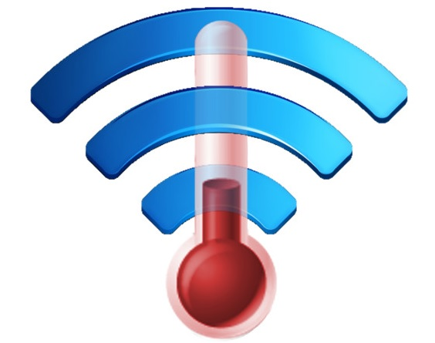

**Jacques Régnière**

**Rémi Saint-Amant**

**Ariane Béchard**

**Ahmed Amine Moutaoufik**

**2017-2018**

**Natural Resources Canada**

**Canadian Forest Service**

**Laurentian Forestry Centre**

**P.O. Box 10380, Stn. Sainte-Foy**

**Quebec, QC Canada, G1V 4C7**

Table of Contents

**1 Weather Updater:** 3

**1.1** **Windows Proprieties:** 3

**1.2** **Windows project:** 4

**1.2.1** **Download Data** 4

**1.2.2** **Tools** 15

# Weather Updater:

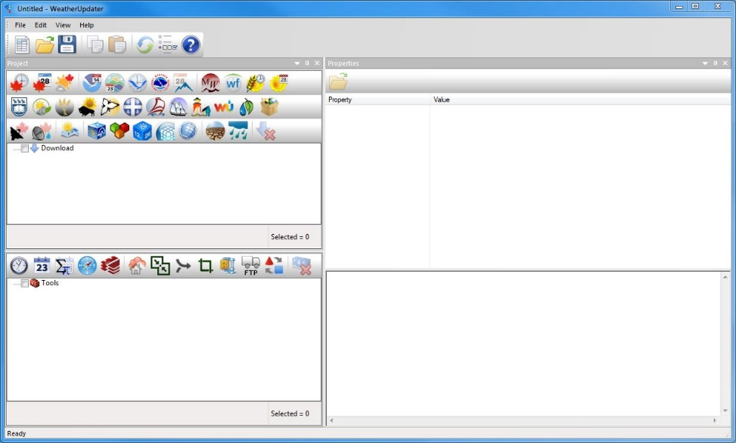The application WeatherUpdater is a software tool allowing to creating, to modify, or to update the meteorological data to create a BioSIM database (hourly, daily, normal and gribs).   
  
The application consists of three windows, the project window, the properties window, and the Output Message Log window.   
  
The WeatherUpdater offers several buttons, which we describe, this below:

New: create a new project .Update.



****Open: open an existing project.

****Save: save the modifications on the active project.

****Copy: copy the selection and the put in the clipboard.

****Paste: insert the clipboard contents.

****Execute: execute checked tasks.

****Options: Show the options of the application.

## **Proprieties Window**

This window allows you to configure the properties of every tasks in the window project, the properties to change according to the chosen task.

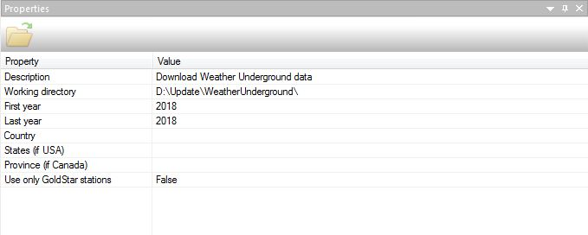

## **Project Window**

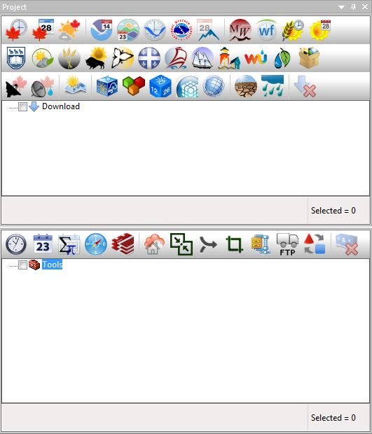The project window is divides into two part, one for the download and update of different sources of weather data. The second part is to creates, modify, import/export different type of BioSIM inputs like databases.

### **Download Data Type**

The section Download Data in the project window allows to choosing between several data types mainly weather data.

**Canada Hourly:** Download hourly data from Environment Canada.

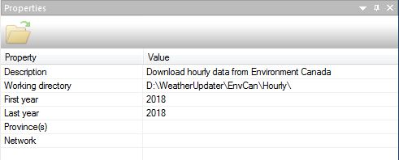**Description**: a brief description on the weather updater task.

**Working directory**: choose the storage directory.

**First year, Last year**: choose the year interval to download data.

**Province(s)**: select the province or provinces for which it will download the data.

**Network**: choose between, History, SWOB or both.

Note: the properties description and working directory, present in all downloads (see below).

**Canada Daily:** Download daily data from Environment Canada.

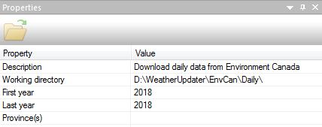Same as Canada Hourly.

The difference between hourly end daily data is that some variable like

**Canada Forecast:** Download hourly forecast from Environment Canada

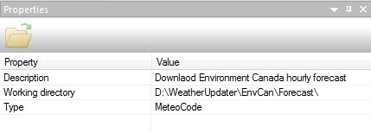

Type: choose between three type MeteoCode, HRDPS (Canada at 2.5Km) or RDPS (North America at 10Km).

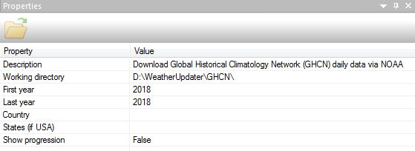**GHCND**: Download Global Historical Climatology Network Daily Data via National Oceanic and Atmospheric Administration (NOAA).

First year, Last year: choose the year interval to download data.

Country: to select the country or countries.

States: to select state or states, if you choose USA in Country.

Show progression: enable or disable the progress window, when a progress window displayed.

**GSOD Daily:** Download Global Surface Summary of the Day Daily data via NOAA.

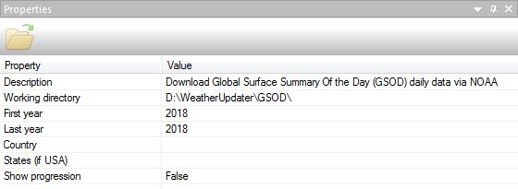

Similar to GHCND.

**ISD-Lite Hourly:** Download Integrated Surface Data Hourly data via NOAA.

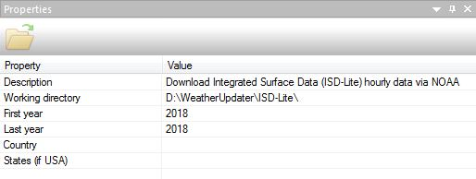

The properties fields described:

First year, Last year: choose the year interval to download data.

Country: to select the country or countries.

States: to select state or states, if you choose USA in Country.

**NOAA Forecast:** Download Weather Forecast from NOAA.

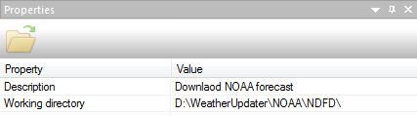

**SNOTEL Daily:** Download Snow Telemetry Daily data via Natural Resources Conservation Service NRCS.

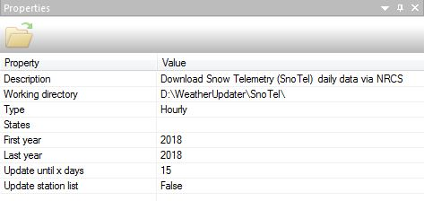The properties fields described:

Type: choose the type of data to download, Hourly, Daily, or Monthly.

States: allow to select one or more US state, for which it will download the data.

First year, Last year: choose the year interval to download data.

Update until x days:

Update station list: enable the update of the station list.

**MesoWest weather:** MesoWest Weather Data.

The properties fields described:

First year, Last year: choose the year interval to download data.

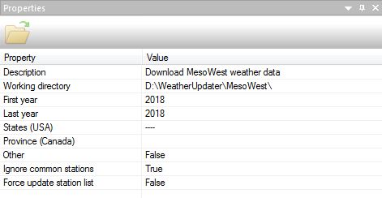States (USA): allow choose one or more US state, for which it will download the data.

Province (Canada): select one or more provinces or territories of Canada, for which it will download the data.

Other:

Ignore common stations: to Ignore common stations.

Force update station list: enable the update of the station list.

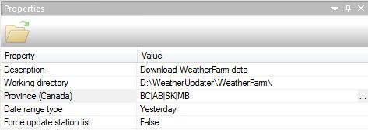**Weather Farm:** WeatherFram: allow to download data via WeatherFram for Canada.  
  
The properties fields described:

Province (Canada): Select one or more provinces or territories of Canada.

Type of period: allow choosing between today, yesterday, last two days, or last three days.

Forced to update the list of stations: allow activating or deactivate the update of the list of stations.

**CIPRA Hourly:** Download agro-climatic Hourly data Québec via Solutions-Mesonet.

The properties fields described:

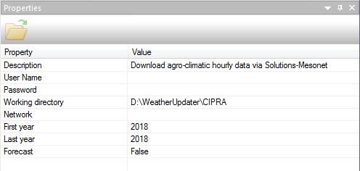

Username, Password:    
Network: Select between Atlantic, Ontario, Pommes, and/or Quebec.  
First year, Last year: Choose the year interval downloaded.  
Forecast: Enable or disable the download of forecasts.

**Québec Daily:** Download Québec daily data via Solution-Mesonet.

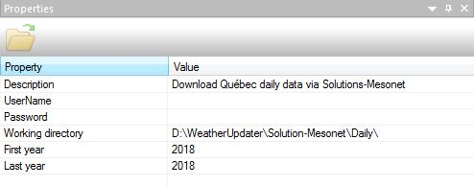

The properties fields described:

First year: Choose the year interval downloaded.

Last year: Choose the year interval downloaded.

**British Colombia Weather:** Download British Colombia Weather data via Pacific Climate Impacts Consortium PCIC.

The properties fields described:

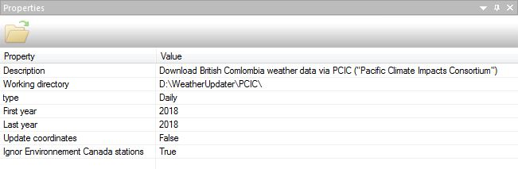Type: Choosing the data type either Daily or Hourly.  
First year, Last year: Allow choosing the year interval downloaded.  
Update Coordinates: To enable or disable contact update.  
Ignored Environment Canada stations: to ignore the download of presale data from environment

**Alberta Weather:** Download agro-climatic for Alberta via AgroClimatic Information Service ACIC.



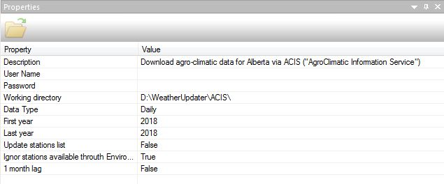 The properties fields described:

User name:

Password:  
Data Type: To choose the data type either Daily or Hourly.  
First year, Last year: Choose the year interval downloaded.  
Update Station List: Activate or deactivate the update of the station list.  
Ignored the available stations by Environment Canada: Allow ignoring the download of the pre-sale data from environment Canada weather stations.  
1 month delay:

**Saskatchewan Weather:** Download Saskatchewan Weather data.

The properties fields described:

Download Archive: to download the archives.

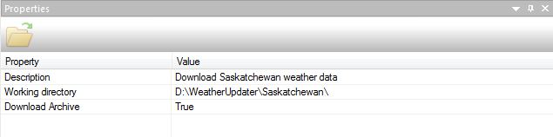

**Manitoba Weather:** Download Manitoba Weather data.



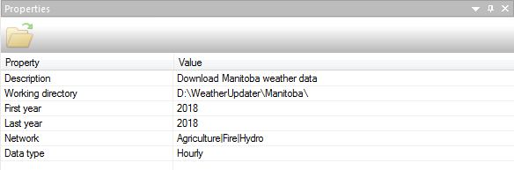The properties fields described:

First year, Last year: To choose the year interval downloaded.

Network: to select one or more data sources, Manitoba Agriculture, Manitoba Fire, and Manitoba Hydro.

Data type: select the data type either Daily, or Hourly.

**Ontario Weather:** Download Ontario Weather data.

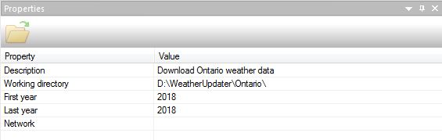

The properties fields described:

First year, Last year: To choose the year interval downloaded.

Network: Select one or more data sources, Ontario Fire Weather Program.

**Québec Weather:** Download Québec Weather data.

The properties fields described:

First year, Last year: To choose the year interval downloaded

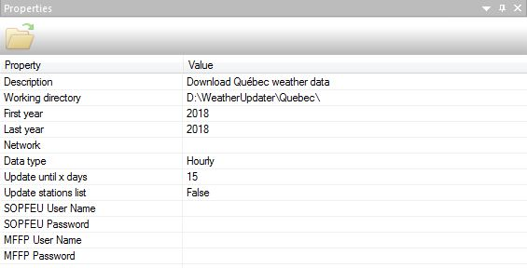Network: Select one or more data sources, SOPFEU, MDDELCC (daily), Hydro-Québec, MFFP, ALCAN, Financière Agricole.

Data type: To choose the data type either daily or hourly.

Update until x day:

Update stations list: Activate or deactivate the update of the station list.

SOPFEU user name / Password: To connect to the server, from the Society of Forest Protection Against Fire, to download the weather data.

MFFP user name / Password: To connect to the server, the Quebec Ministry of Forests, Wildlife and Parks.

**New-Brunswick Weather:** Download New-Brunswick Weather data.

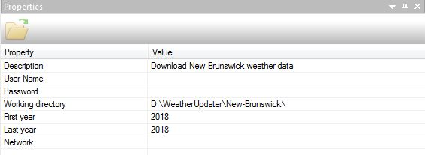The properties fields described:

Username /Password: connect to ftp.gnb.ca to download the weather data.  
First year / Last year: Choose the year interval downloaded.  
Network: Select one or more data sources, Fire (historical Data or Current Data), and Agriculture.

**Nova-Scotia Weather:** Download Nova-Scotia Weather data.

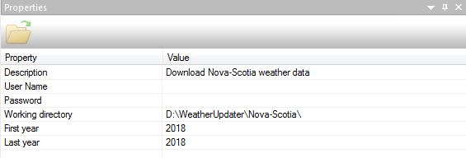The properties fields described:

Username /Password: connect to ftpque.nrcan.gc.ca to download the weather data.

First year / Last year: Choose the year interval downloaded.

**Newfoundland Weather:** Download Newfoundland Weather data.

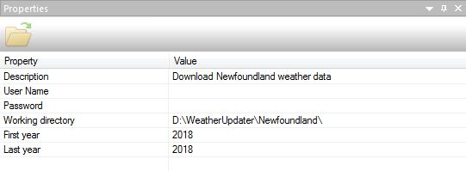The properties fields described:

User name /Password: connect to ftpque.nrcan.gc.ca to download the weather data.

First year / Last year: Choose the year interval downloaded.

**Weather Underground:** Download Weather Underground data.

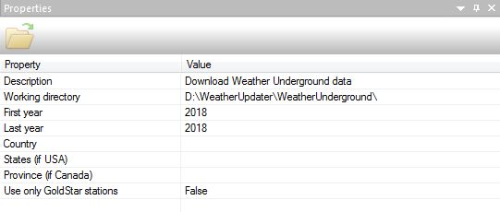The properties fields described:

First year / Last year: Choose the year interval downloaded.

Country: Select one or more countries, to download the weather data.  
States (USA): Select one or more states, United States.  
Province (Canada): Select one or more Canadian provinces, if Canada selected from the list of countries.  
Use only GoldStar stations: Use GoldStar stations, Weather Underground only.

**NEWA:** Download Network for Environment and Weather Applications (NEWA).



The properties fields described:

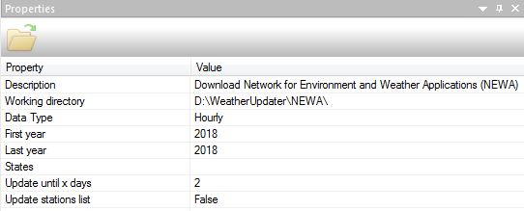

Data Type: To choose the data type either Daily or Hourly.  
First year / Last year: Choose the year interval downloaded.

States: Select one or more states, the United States.

Update until x Days:

Update station list: Activate or deactivate the update of the station list.

**Miscellaneous:** Download data from miscellaneous sources.

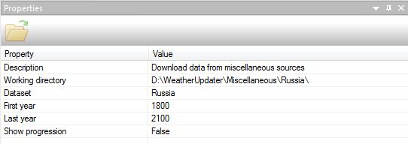The properties fields described:

Dataset: Choose between Russia, SOPFEU 2013, or Quebec Schedule.

First year / Last year: Choose the year interval downloaded.  
Show progression: Display the progress window during the execution

**Radar Images:** Download Radar Images data from Environment Canada (GIF format).

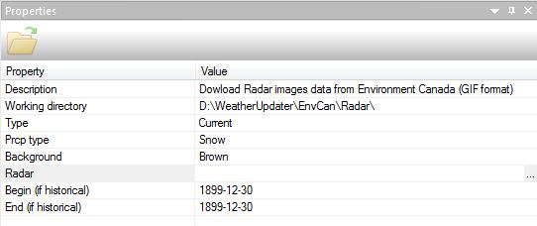The properties fields described:   
  
Type: Choose between Current or Historical image Radar.  
Prcp type: Choose the type of precipitation between precipitation of snow, or rain.  
Background: Choose between two colors as either white or brown background.  
Radar: Select one or more radars across Canada.  
Begin (if historical): If the type is history, select the start date for the radar image download.  
End (if historical): If the type is history, select the end date of the radar image download.

**Radar Precipitation:** Download Precipitation Radar data from Environment Canada (gribs format).

The properties fields described:

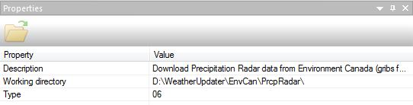Type: Choose between two modes, grib file per day if the type is 24, or a file for every 6 hours if the type is 6.

**HIRESW:** Download High-Resolution Window via National Centers for Environmental Prediction (NCEP).

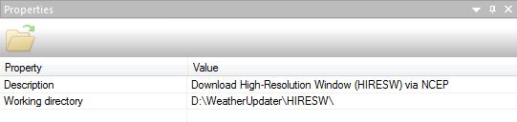

**RAP 3D Gribs:** Download Rapid Update Cycle 3D gribs via NOAA Operational Model Archive and Distribution System (NOMADS).

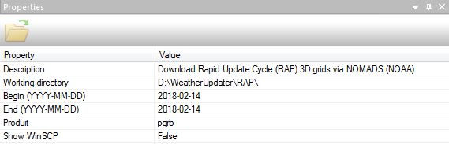The properties fields described:

Begin: The start date to download the GRIB data

End: The end date of the download GRIB data.

Product: Choose between two types of data bgrb, or pgrb.

Show WinSCP: Enable or disable the display of the WinSCP window display the progress of data loading.

**NAM 3D Gribs:** Download North American Mesoscale Forecast System (NAM) 3D gribs via NOMADS.

The properties fields described:

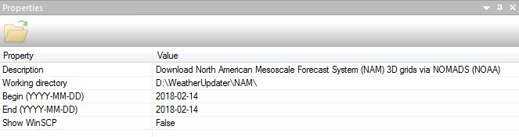

Begin: The start date to download the NAM data.

End: The end date of download NAM data

Show WinSCP: Enable or disable the display of the WinSCP window, show the progress of loading data.

**HRDPS 3D Gribs:** Download High Resolution Deterministic Prediction System (HRDPS) 3D gribs via Environment Canada.

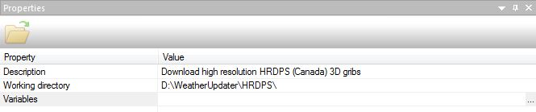

The properties fields described:

Variables: Choose the variables to download (temperature, precipitation ...), to select the variables, click on (...) button to open a list of variables.

**HRRR 3D Gribs:** Download High Resolution Rapid Refresh (HRRR) via NOAA.

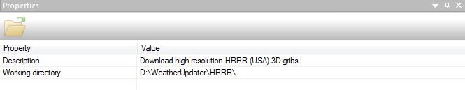

**3D Gribs Forecast:** Download 3D gribs forecast.

The properties fields described:

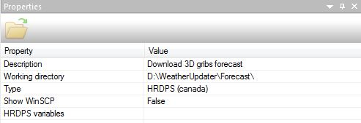

Type: Choose a GRIB data type between HRDPS (Canada), HRRR (USA), RAP P (Canada / USA), RAP B (Canada / USA), or NAM (Canada / USA).

Show WinSCP: enable or disable the display of the WinSCP window display the progress of data loading.

HRDPS variables: Choose variables if the type is HRDPS.

**CMIP5:** Download Daily Coupled Model Intercomparison Project phase 5 (CMIP5) data via Program for Climate Model Diagnosis & Intercomparison (PCMDI).

The properties fields described:

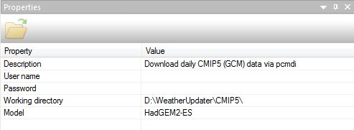

User Name /Password: Username: allow login to download data.  
  
Model: Choosing a model the only one available is HadGEM2-ES.

**GPCP:** Download daily Global Precipitation Climatology Project (CGCP) data via The NASA.

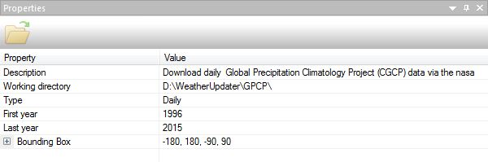

The properties fields described:

Type: Choose the type of data, either daily, or monthly.

First year: Define the data start year.

Last year: Define the end year of the data.

**Remove**: to delete a task from Download.

### **Tools**

The tools section in Weather updater allow creating hourly, daily, normal or gribs databases for the used in BioSIM 11 or 10

**Create Hourly DB:** Create an hourly database.



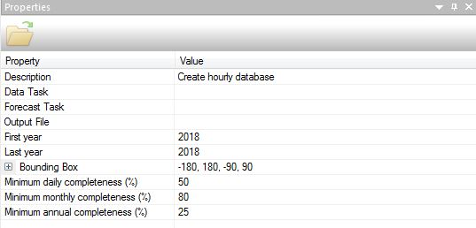The properties fields described:

Description: Brief description on the tool.

Data Task: Choose a weather downloader from the task download list.

Forecast Task: Choose a weather forecast downloader from the task download list.

Output File: Choose the output file directory.

First year: Choose the start year.

Last year: Choose the end year.

Minimum daily completeness (%):

Minimum monthly completeness (%):

Minimum annual completeness (%):

**Create Daily DB:** Create Daily database.

The properties fields described:

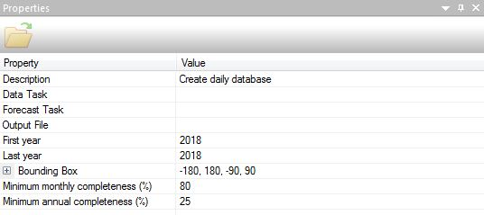Description: Brief description on the tool.

Data task: Choose a weather downloader from the task download list.

Forecast Task: Choose a weather forecast downloader from the task download list.

Output file: choose the output file directory.

First year: the beginning year.

Last year: the end year.

Rectangle:

Minimum monthly completeness (%):

Minimum annual completeness (%):

**Create Normals DB:** Create Normals database from Daily database.

The properties fields described:

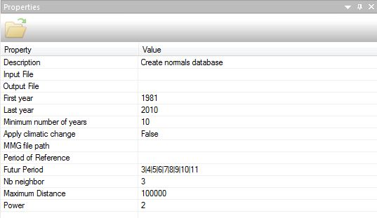

Input file: Select the directory of the input file.

Output file: Select the output file directory.

First year: Choose the start year.

Last year: Choose the end year of the normal database.

Minimum number of year: Choose the minimum number of years shown in the normal database.

Apply climatic change:

MMG file path:

Period of Reference: Choose a reference period according to list.

Future Period: Select future periods according to a list.

Nb neighbor: Set the number of neighbors.

Maximum Distance: Set the maximum distance.

Power:

**Create Gribs:** Create Gribs database.

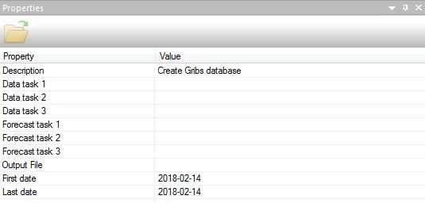

The properties fields described:

Data task 1/2/3: to choose a weather downloader from the task download list.

Forecast task 1/2/3: to choose a weather forecast downloader from the task download list.

Output file: Select the output file directory.

First date: Choose the start year.

Last date: Choose the end year of the Gribs database.

**Create MMG:** Create Monthly Mean Grid.



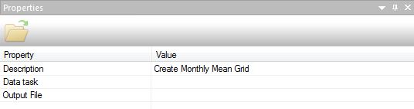

The properties fields described:

Data task: Select a weather downloader from the task download list.

Output file: Select the directory, and the name of the output file (.mmg).

**Virtual DB:** Create Virtual database from Gribs database file.

The properties fields described:

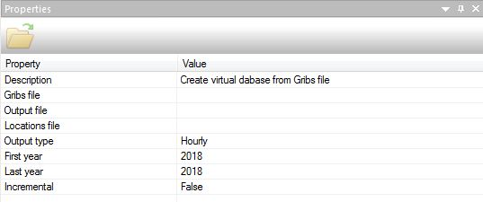  
Gribs file: Select the Grib database as an input file.  
Output file: Select the directory, and the name of the database of time or day.  
Location File: Choose the location file (.csv).  
Output Type: Choose either the type of output database, hourly (.HourlyBD), or daily (.DailyBD).  
First year: Choose the start year, the output database.  
Last year: Choose the end year, from the output database.  
Incremental:

**Merge:** Merge two weather database.

The properties fields described:

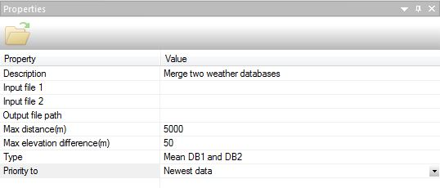Input file 1: Allow choosing the first database to merge, either schedule (.HourlyDB), daily BioSIM 11 or 10 (.DailyBD or .DailyStations), Normals (.NormalsDB, .Normals), or GRIB (. gribs).  
Input file 2: Allow choosing the second database the same as the first.  
Output file path: To choose the output directory, the name, and the type (.HourlyDB, DailyBD, .DailyStations, .NormalsDB, .Normals, .gribs) of the output database.  
Max distance (m): Set the maximum distance in meters.

Max elevation difference (m): Set the elevation difference in meters.

Type: Choose between three actions to take, either to take the value of BD1, Average between BD1 and BD2, or take the value of BD2.  
Priority to: Choose the priority between 'Largest amount of data', 'Greatest Number of Years', 'Oldest data', or 'Newest data'.

**Append:** Append one database into an other database.

The properties fields described:

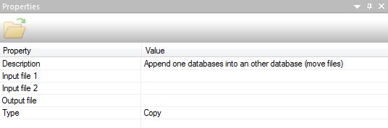Input file 1: Choose the first database to merge, either schedule (.HourlyDB), daily BioSIM 11 or 10 (.DailyBD or .DailyStations), Normals (.NormalsDB, .Normals), or GRIB (.gribs).  
Input file 2: Choose the second database the same as the first one.  
Output File: Select the output directory, name, and type (.HourlyDB, DailyBD, .DailyStations, .NormalsDB, .Normals, .gribs) from the output database.  
Type: Choose between two actions, either copy, or move.

**Crop:** Crop weather database.

The properties fields described:

Input file: Select the database to gnaw, either schedule (.HourlyDB), daily BioSIM 11 or 10 (.DailyBD or .DailyStations), Normals (.NormalsDB, .Normals), or GRIB (.gribs).

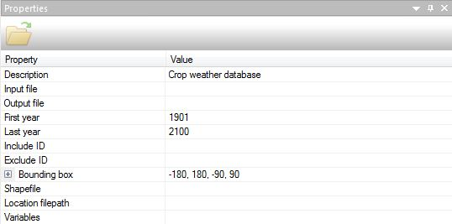Output file: Choose the output directory, name, and type (.HourlyDB, DailyBD, .DailyStations, .NormalsDB, .Normals, .gribs) from the output database.

First year: Choose the data start date.

Last year: Choose the end date of the data.

Include ID:

Exclude ID:

Shape file: Select the Shape file.

Location file path: Select the .csv location file  
Variables: Select the meteorological variables.

**Zip/Unzip:** Zip or Unzip file.

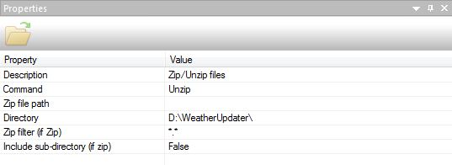The properties fields described:

Command: Choose the command to do either compress or decompress.

Zip file path: allow the zip file to decompress in decompress mode, or allow choosing the output directory and the file name to compress mode.

Directory: Select the output directory to unzip mode, or allow directory to enter the zip mode.

Zip filter (if zip): Choose to filter the files before compression in zip mode.

Include sub-directory (if zip): Choose to either include subdirectories or not.

**FTP:** Download or Upload a file from or to a FTP site.

The properties fields described:

Direction: Choose between download or upload.

Server: Enter the server name.

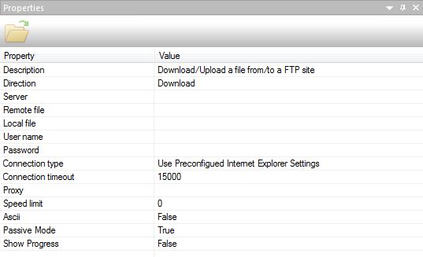Remote file: Enter the full path of the file.

Local file: Select the local directory for the backup of the file in the case of the download or the source file in the case of uploading.

User name / Password: Log in with a username and password in case the FTP site and password protected.

Connection type: Choose between three types of connection, use the pre-configured Internet Explorer settings, Use a direct connection, or use a connection through the proxy server.

Connection timeout: Set the connection time in milliseconds.

Proxy: Allow entering a proxy.

Speed limit: Allow limiting the speed of download or upload.

ASCII:

Passive Mode:

Show Progress: Display a window with the progress bar.

**Convert DB:** Convert database from BioSIM 11 to BioSIM 10 and vice versa.

The properties fields described:

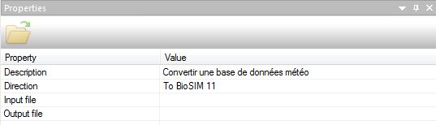Direction: Choose between two directions, from BioSIM10 to BioSIM11 or from BioSIM 11 to BioSIM10.  
Input file: Select the database to convert.  
Output file: Choose the directory and the name of the output database.

**Remove**: to delete a task from Tools.